Name:____________________
Date:_____________________
By Katrina Apelles
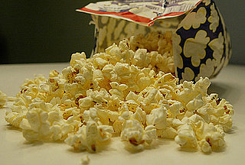

Imagine going to the grocery store and not knowing which kind of popcorn to buy. Maybe you want the most butter in the popcorn. Or maybe you want the best buy because you are trying to save money on your shopping bill. Or you may want to have more popped corn than not popped kernels. To choose the best popcorn for your family, you may want to do this experiment at home.
Materials:
- 6 bowls
- 3 different brands of microwavable popcorn
- A microwave
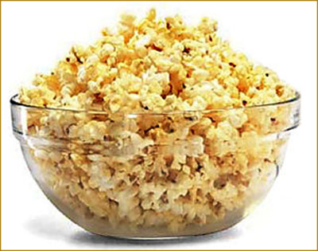
Procedure:
- Microwave three different bags (different brands) of popcorn.

- Each team will count the amount of popped corn and not popped kernels from a bag of popcorn.

- The groups will then put all of the data together and find the percent popped to not popped for each brand of popcorn using the correct formula.

- The groups will then compare the data collected to the original data to find a percent error.

- Find out which brand of popcorn is the best price per bag of popcorn.

Percent of popped and not popped popcorn:
 | My results | Class results
Hannaford (popped) | 92.15%
(not popped) | 7.85%
Orville Redenbacher’s (popped) | 88.66%
(not popped) | 11.34%
Pop Secret (popped) | 94.74%
(not popped) | 5.26%

Analyze Data:
To find the percent of popped popcorn and not popped popcorn, use the following formulas:
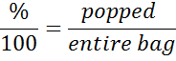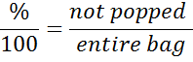
to decide which bag has the most popped and the least not popped popcorn. Also you can use the formula 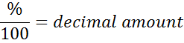 to obtain the decimal.
Popcorn | Percent  $$\frac{\%}{100}=\frac{popped or (not)}{entire bag}$$ | Decimal  $$\frac{\%}{100}=$$
Hannaford Brand  Popped | $$\frac{\%}{100}=\frac{ }{ }$$ | $$\frac{\begin{aligned} \\ \end{aligned}}{100}=$$
Hannaford Brand  Not popped | $$\frac{\%}{100}=\frac{ }{ }$$ | $$\frac{\begin{aligned} \\ \end{aligned}}{100}=$$
Orville Redenbacher’s  Popped | $$\frac{\%}{100}=\frac{ }{ }$$ | $$\frac{\begin{aligned} \\ \end{aligned}}{100}=$$
Orville Redenbacher’s  Not popped | $$\frac{\%}{100}=\frac{ }{ }$$ | $$\frac{\begin{aligned} \\ \end{aligned}}{100}=$$
Pop Secret  Popped | $$\frac{\%}{100}=\frac{ }{ }$$ | $$\frac{\begin{aligned} \\ \end{aligned}}{100}=$$
Pop Secret  Not popped | $$\frac{\%}{100}=\frac{ }{ }$$ | $$\frac{\begin{aligned} \\ \end{aligned}}{100}=$$

Percent Error Calculation:
Using the following formula, plug in my results for the true value and your results in the experimental value.
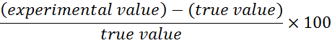
Popcorn | Percent Error
Hannaford Brand  Popped | $$\frac{\begin{aligned} \\ \end{aligned}}{ }×100=$$
Hannaford Brand  Not popped | $$\frac{\begin{aligned} \\ \end{aligned}}{ }×100=$$
Orville Redenbacher’s  Popped | $$\frac{\begin{aligned} \\ \end{aligned}}{ }×100=$$
Orville Redenbacher’s  Not popped | $$\frac{\begin{aligned} \\ \end{aligned}}{ }×100=$$
Pop Secret  Popped | $$\frac{\begin{aligned} \\ \end{aligned}}{ }×100=$$
Pop Secret  Not popped | $$\frac{\begin{aligned} \\ \end{aligned}}{ }×100=$$

As a class, were your observations similar to the results given? Why do you think the results were(n’t) similar.
_____________________________________________________________________________________________________________________________________________________________________________
How many pieces of popcorn popped and not popped in box?
Hannaford brand:

$\frac{ }{ }=\frac{ }{ }$ x=______________

$\frac{ }{ }=\frac{ }{ }$ y=________________

__________-____________=
Orville Redenbacher’s

$\frac{ }{ }=\frac{ }{ }$ x=______________

$\frac{ }{ }=\frac{ }{ }$ y=________________

__________-____________=
Pop Secret

$\frac{ }{ }=\frac{ }{ }$ x=______________

$\frac{ }{ }=\frac{ }{ }$ y=________________
__________-____________=

Connections:
- What else could this experiment be used for besides popcorn?

- What are some factors that may have contributed to the values to be different?
Other Questions:
- Which popcorn has the best, buttery flavor?
- Which popcorn has the most popped corn in the bag?

